##### Enhancement of PD diagnosis and early detection using Multi-modal data

Nikhil Sharma

23MCS0020

*MTech, CSE, SCOPE*

VIT Vellore, TN, India

[nikhil.sharma2023a@vitstudent.ac.in](mailto:nikhil.sharma2023a@vitstudent.ac.in)

Bhavesh Kumar Modi

23MCS0045

*MTech, CSE, SCOPE*

VIT Vellore, TN, India

[bhavesh.kumar2023a@vitstudent.ac.in](mailto:bhavesh.kumar2023a@vitstudent.ac.in)

Anil Kumar K

Associate Professor Sr, SCOPE

VIT Vellore, TN, India

[anilkumar.k@vit.ac.in](mailto:anilkumar.k@vit.ac.in)

***Abstract:* Parkinson's disease (PD) remains a major challenge in medicine due to its progressive and debilitating nature. Early-stage detection with high accuracy still eludes clinicians. This research aims to use advances in machine learning, particularly deep learning algorithms, to address this challenge. Focusing on common neurodegenerative movement disorders such as PD, we aim to identify key symptoms and determine optimal treatment starting points to mitigate its impact. Our research explores the integration of step sensor data with other motor, non-motor, and brain imaging data to improve diagnostic accuracy. We aim to improve the clinical diagnosis of PD by comprehensively analyzing multimodal data, including step sensors and motor and non-motor symptoms. By combining features from different modalities, we expect to achieve better accuracy in PD prediction than single modal approaches. In addition, this study represents a pioneering work in the field of computer vision combining the characteristics of different subjects and methods. The application of deep learning techniques promises to unlock new insights and potential breakthroughs in the prediction and management of PD.**

Keywords: ***Parkinson's disease, deep learning, multimodal data, gait sensor, brain imaging, classification, non-invasive diagnosis, Deep neural networks, Feature extraction, Feature fusion.***

1. **Introduction**

Parkinson's disease, a notoriously incurable disease of the central nervous system, has affected nearly 8.5 million people worldwide. The symptoms of this disease appear slowly and impair a person's motor function. Some early symptoms include stiffness, tremors, slowness of movement, difficulty walking and some behavioural problems. These symptoms are more visible in the late stages of this disease. We still do not know the root cause of Parkinson's disease, and researchers are still trying to figure out if there are similarities between people with PD. We have seen patients in the advanced stages of this disease suffer from muscle stiffness, loss of smell, rapid eye movements and sleep disturbances that affect daily life. Although we often do not notice the mild symptoms of this disease in the early stages, and after a few years these symptoms turn into a chronological neurodegenerative disorder. Parkinson's disease is difficult for researchers and doctors to diagnose in its early stages because of its many co-morbidities. Observations made over several months give us a clear picture of a person's symptoms. Today's advances in machine learning and deep learning techniques have paved the way for doctors to diagnose Parkinson's disease. Researchers began experimenting with this disease and patient symptoms. In the early stages of this experiment, several authors looked only at the similarity finding direction of the same patients. However, researchers later discovered that several variables play a role in this process of diagnosing Parkinson's disease. Testing only one type of symptom gives us accuracy only for certain types of data. However, we saw that a patient with Parkinson's disease can have some other symptoms that we missed during the study. Thus, researchers arrived at PD differential identification, which considers several symptoms of this disease and characterizes an individual as a PD patient or a healthy control. The above consideration is not enough because almost 100% accuracy is required and the mentioned technique has a high error rate in detecting Parkinson's disease.

Researchers have found that the problem of clinical diagnosis of PD is mainly since clinical identification is based on clinical tests and patients' responses to various drugs using neuroimaging of the brain. Another challenge we have already talked about is early detection. In this scenario, the internal structure of the brain changes, resulting in some subtle symptoms. A brain scan of a PD patient shows that the most affected areas are the substantia nigra and the basal ganglia. Due to the loss of neurons, the disease manifests itself in the patient with dopaminergic activity, which is much before the motor symptoms. Doctors usually try to detect PD in early stage so that neuroprotective medicine can slow the progression of the disease and help prevent the clinical symptoms of PD. The use of ML techniques for PD detection has become more common in the past decade and so on. This algorithm helps to find a pattern in clinical data or images and tries to classify patients with PD and HC. In this experiment, we try to classify patients with Parkinson's disease based on gait sensors and brain MRI images.

We have previously seen that brain imaging can help diagnose patients with PD. Also, gait analysis studies human movement, body mechanics and muscle activity. This is usually done by using several sensors attached to the leg and collecting pressure sensor data from that data over a period of two to three minutes. The neurosurgeon analyses the result and determines whether the patient has PD or not, based on his knowledge and visual experience. These are two different data sources where there is no relationship between the records in the two datasets because the patients in both datasets are different. In this scenario, we planned to use a multimodal framework to fully combine the features of each dataset to classify PD and healthy control subjects more efficiently and accurately. We test this concept in each dataset where we observe improvements in the use of gait data in combination with brain images, DNA-RNA samples, and clinical data from the PPMI database. In medical diagnosis, we have seen doctors make their decisions based on multiple medical diagnoses such as MRI, CT, SPECT, f-MRI images, as well as clinical measurements such as motor and non-motor symptom data. But usually, the problem is always the lack of medical images of the patient due to MRI, CT machine or other critical situations.

1. **Literature review**

In recent research endeavours, investigations into Parkinson's disease (PD) have been broadly categorized into three domains: 1) Exploration of machine learning techniques for distinguishing between PD and healthcare-associated dementia,

2) Differential diagnosis studies, and

3) Efforts aimed at the early detection of PD.

The subsequent subsection delves into the utilization of machine learning (ML) methodologies in imaging investigations, particularly focusing on PET, SPECT, structural MRI, and functional MRI (fMRI) images.

Within the realm of research aimed at distinguishing between PD and healthy controls (HC) using machine learning techniques, it has been recognized that data from singular sources often fail to adequately capture critical PD behaviours. Consequently, researchers have increasingly turned to the integration of imaging and clinical data, especially when dealing with data measured on varying scales for classifying PD patients. For instance, S. Ghosh, P.K. Mandal, S. Dutta Roy, and Prashanth [20] concluded that amalgamating cerebrospinal fluid (CSF), non-motor, and imaging data holds promise for the preclinical diagnosis of PD. Enrico Glaab [5] and colleagues demonstrated the efficacy of combining blood sample data with PET images to enhance the diagnostic accuracy in distinguishing between PD patients and healthy controls. Similarly, Thomas J Hirschauer and collaborators [19] proposed an innovative approach that incorporates brain neuropathological information alongside motor and non-motor symptom data within an enhanced probabilistic neural network framework, yielding superior results compared to conventional machine learning algorithms.

Moving beyond the binary classification of PD versus HC, studies utilizing machine learning techniques have ventured into investigating various PD diagnoses. Given the heterogeneity within PD, it is imperative to delineate different subtypes for tailored treatment strategies. Recent endeavours have leveraged dopaminergic imaging, structural MRI, functional MRI, and diffusion tensor imaging in conjunction with popular machine learning algorithms such as SVM and logistic regression to differentiate between PD subtypes. Notably, the integration of multimodal features has emerged as a promising approach in this regard. For instance, Andrea Cherubini and colleagues [11] combined DTI imaging with voxel-based morphometry using a support vector machine to differentiate between Progressive Supranuclear Palsy (PSP) and PD patients, demonstrating the utility of automatic pattern recognition in distinguishing between distinct PD subtypes. Similarly, G. Two, M.M. Lewis, S. Kanekar, and collaborators [21] highlighted the significance of apparent transverse relaxation rate and DTI imaging as valuable markers for differential PD diagnosis.

Furthermore, efforts have been directed towards the early identification of PD to facilitate timely interventions that may slow disease progression. Studies have explored the integration of imaging data with clinical information to enhance the initial diagnosis of PD. For instance, Dan Long, Jinwei Wang, and colleagues [18] utilized structural data and resting-state functional MRI data to classify early PD patients based on features such as ALFF, RFCs, ReHo, cerebrospinal fluid (CSF), grey matter (GM), and white matter (WM). Their approach achieved an accuracy of nearly 87%, surpassing single-source image data. Similarly, Oliveira et al. [17] investigated SPECT image data, extracting features from each brain hemisphere, and employing classical machine learning techniques. Notably, their study achieved a classification accuracy of 97% when utilizing all features collectively, underscoring the potential of integrated imaging and clinical data for improving early PD diagnosis.

Despite the progress made, several limitations and challenges persist in the field. Clinical diagnostic data are inherently flawed, necessitating caution when relying solely on clinical data for PD classification. In addition to supervised learning methods, the application of unsupervised techniques holds promise for more accurate data labelling by uncovering underlying data patterns. However, these techniques encounter technical challenges when applied to image data due to their inability to extract image features. Moreover, the black-box nature of machine learning models poses challenges in understanding the underlying mechanisms, conflicting with the principles of evidence-based medicine. Efforts are thus needed to elucidate disease-specific features using machine learning approaches. Furthermore, mitigating the risk of overfitting remains a significant challenge, particularly given the excessive heterogeneity in PD data, underscoring the importance of large-scale data collection and robust validation methods to enhance model generalizability.

1. **Proposed Problem Statement**

We have developed a multi-modal framework that uses two distinct data sources for disease categorization after gaining a thorough grasp of the constraint. To effectively execute the task of diagnosing Parkinson's disease, we have integrated imaging, clinical, and gait analysis data. In addition, we have successfully eliminated the over-fitting issues by using an effective cross-validation technique. To increase the process's dependability for clinical diagnosis, we have attempted to lower the categorization mistake rate. Additionally, the goal of this experiment was to use multimodal features to classify single modal data more accurately. Thus, as a group, we may sum up our involvement in this experiment as follows:

* Utilizing multimodal data to enhance the early identification and diagnosis of Parkinson's disease.
* Integrating characteristics from MRI and gait analysis data.
* Enhancing and validating the model to improve precision and reliability.
* Reducing diagnostic error rates.
* Evaluating the framework's performance using a single-modal approach.

1. **Description of the Dataset**

We will be using two datasets in this experiment. The Gait dataset comes from the Physio Net database, while the clinical and brain image data comes from the PPMI database. We went into great length on the datasets in the ensuing subsection.

**4.1 PPMI Dataset:**

Another dataset used in this experiment was collected from the Parkinson's Progression Markers Initiative (PPMI) database. This database, also known as a multicentre and international study, contains records used to detect signs of PD for diagnosis and to detect disease progression. This database stores data in a specific format where participants must go through 6 clinical assessments and neuroimaging data for two important brain regions. Of the 1141 participants whose data are stored in the PPMI archive, 666 participants will be included in this database, representing 58.4% of all participants who completed all the clinical and diagnostic assessments. Now, of the 666 participants whose data were included in the study, 189 participants, 28.4 percent, were diagnosed with PD, while 62 individuals, 9.3 percent of all participants, have scans without dopaminergic deficits, and the rest. 415 participants. that is, 62.3% are healthy participants.

* All clinical data will be collected during 12 visits, as well as initial treatment result.
* Here, clinical motor assessment data is tracked every three months in the first year and every six months the following year.
* Behavioural and cognitive diagnoses were performed every 12 months for all subjects
* VMAT-2 (Australia only) or AT imaging data were recorded at 12 months, 24 months, and 48 months. - Monthly visits for PD patients and participants with SWEDD included a 24-month visit, and health checks were only recorded at baseline.
* Each participant will have an MRI at baseline, and nearly 50% of subjects will have DTI imaging at baseline, and DAT imaging will also be performed at the same longitudinal intervals.
* During the first year, subsequent blood draws were scheduled every three months, followed by another every six months.
* CSF data were collected from each participant at six- and twelve-month intervals and then at 12-month intervals.
* Everyone gets a urinalysis every 12 months.

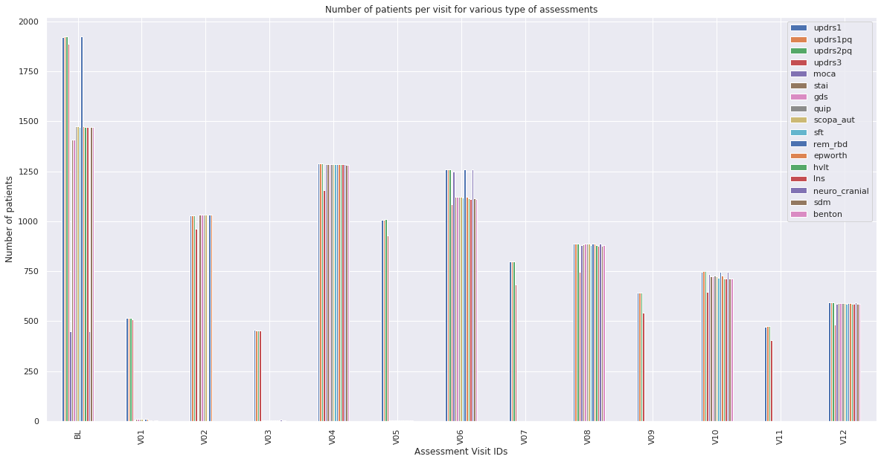

*Fig 1: Distribution of Clinical Diagnoses across Visits*

Prior to commencing the study, we have observed the

distribution of each of the clinical assessments across multiple visits, ranging from the individual's first treatment (Baseline) to their final visit. This database has 13 patient visit records in total. It is evident from the bar-plot distribution graph above that not all assessment records were obtained for all trips. Thus, only visits with the clinical assessment record are to be considered. For this analysis, we have chosen visits 02, 04, 06, 08, 10, and 12 in addition to the first visit. A total of 476 patients have been recognised as having taken part in all assessments up until the most recent visit.

**4.2 Gait Analysis Data:**

The Physio net Gait database contains gait analysis data from 93 individuals diagnosed with Parkinson's Disease (PD) and 73 healthy controls. The average age for both groups is 66.3 years, with a majority being male. This dataset records the vertical ground force exerted by subjects while walking normally for nearly 2 minutes on flat ground. Each leg is equipped with eight sensors capturing force overtime at a sampling rate of 100 Hz. Additionally, demographic details such as disease severity using the Hoehn and Yahr staging and the Unified Parkinson’s Disease Rating scale are provided. To improve readability, the time series data for each patient has been converted into a more understandable format. Furthermore, the sensor data has been transformed into seven statistical measurements to retain all information.

1. **Experiment**

Prior to combining the two datasets into a multi-modal framework, we conducted some analysis on each dataset independently to determine the degree of accuracy that would result from using each dataset independently.

**5.1 PPMI Dataset:**

We will use the PPMI dataset to identify potential biomarkers of Parkinson's disease, such as motor-based and non-motor-based symptoms that are noted following a patient's various clinical diagnosis. The purpose of this analysis was to divide people with Parkinson's disease into three groups according to how quickly the disease was progressing. Four motor-based symptom data, one neuro-logical evaluation data, and twelve non-motor-based symptom data records have all been taken into consideration, giving us a total of 1595 throughout the many visits previously indicated. We have developed a little neural network model that is like the Gait model and is explained below:

* The second layer is another 1D convolutional layer with shape 128 and "Replay" activation function.
* The third layer is a drop layer with an interruption probability of 0.5.
* The next layer is a 1D convolution layer with shape 64 and activation function "Replay".
* The fifth layer is a simple layer with a drop probability of 0.5.
* Then the next layer is a fully connected dense layer with a shape of 32 and an activation function set to "Relu".
* And the output layer is also a fully connected dense layer with an output form of 2 and an activation function of "SoftMax".

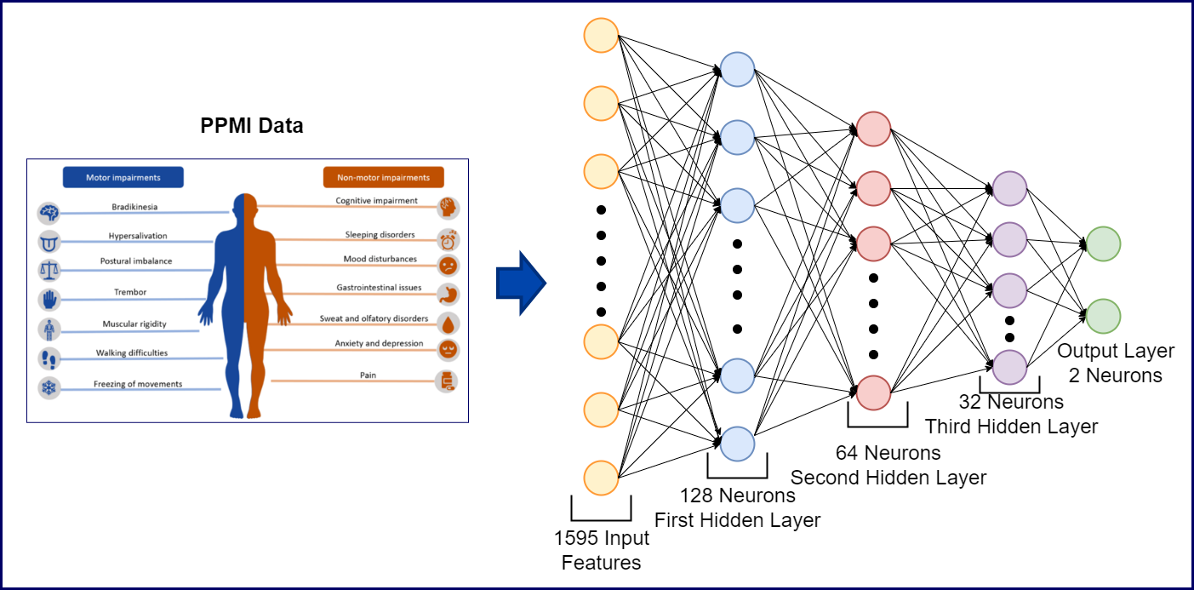

*Figure 4: PPMI Data Neural Network Model.*

Like the Gait model we have chosen “Sparse Categorical Cross-Entropy” as the loss function with “RMSprop” optimizer and learning rate as 0.0001. We have run this model for 15 epochs with a batch size of 5 and it resulted in accuracy of 92.05% along with Cohen Kappa score of 0.8329 and ROC AUC score as 0.9391. From the below results we can observe there is a scope for achieving higher accuracy along with better AUC score. Also, we need to reduce miss classified PD data as for small test set it is still more.

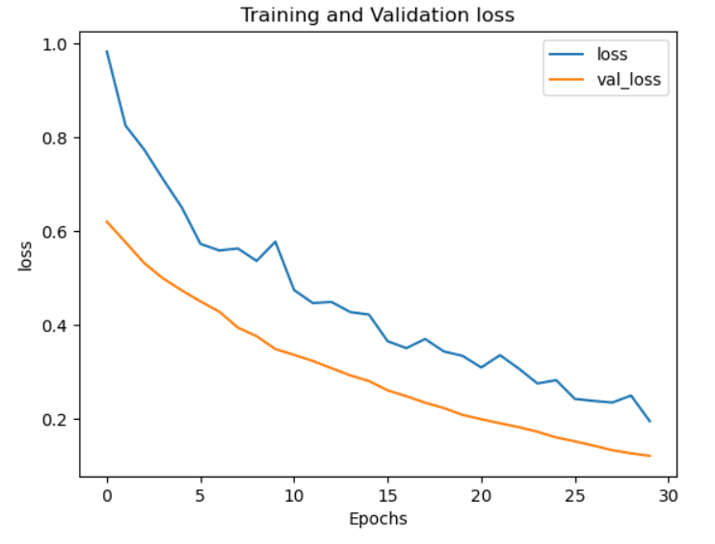

*(a) Training and Validation loss*

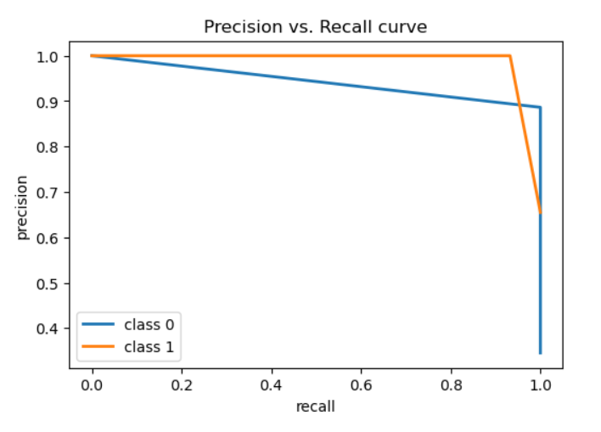

*(b) Precision vs. Recall curve*

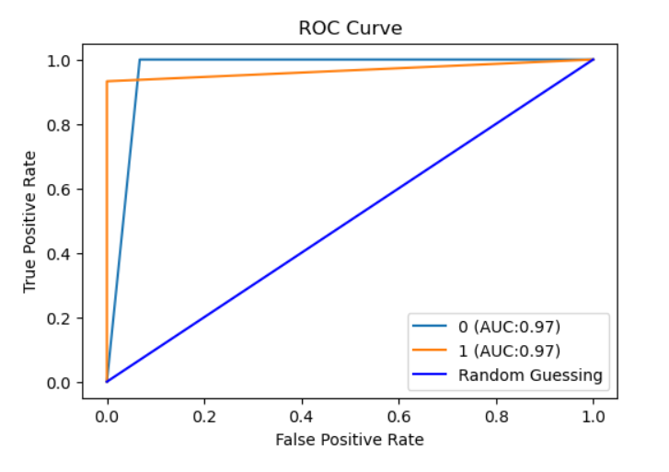

*(c) ROC Curve*

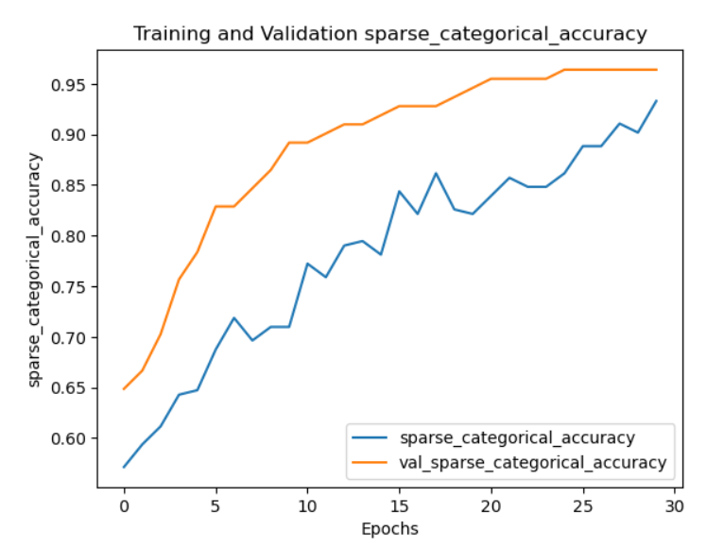

*(d) Training and Validation accuracy*

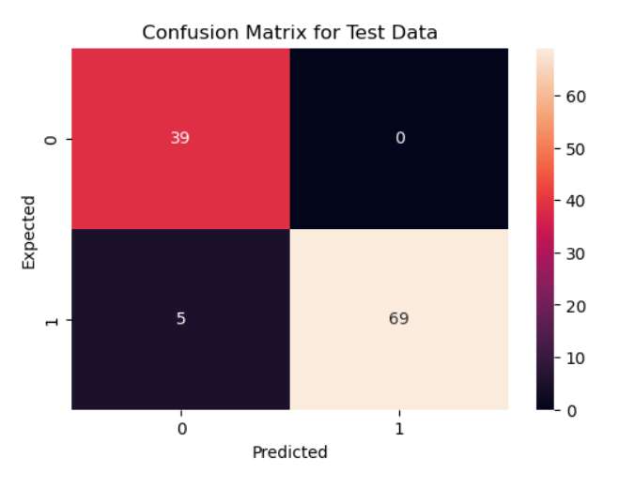

*(e) Confusion Matrix on Test Data*

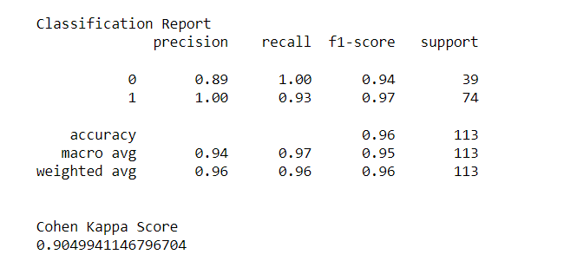

*(f) Classification Report*

*Fig 5: Result using PPMI Model on PPMI data*

**5.2 Gait Dataset:**

We experimented with a deep learning model for the earliest phase of Parkinson's disease detection using only motor-based symptoms, using the Physio net Gait dataset. For this analysis, we have constructed a tiny convolutional neural network model that includes a 1D convolutional input layer in addition to various more layers that are detailed below:

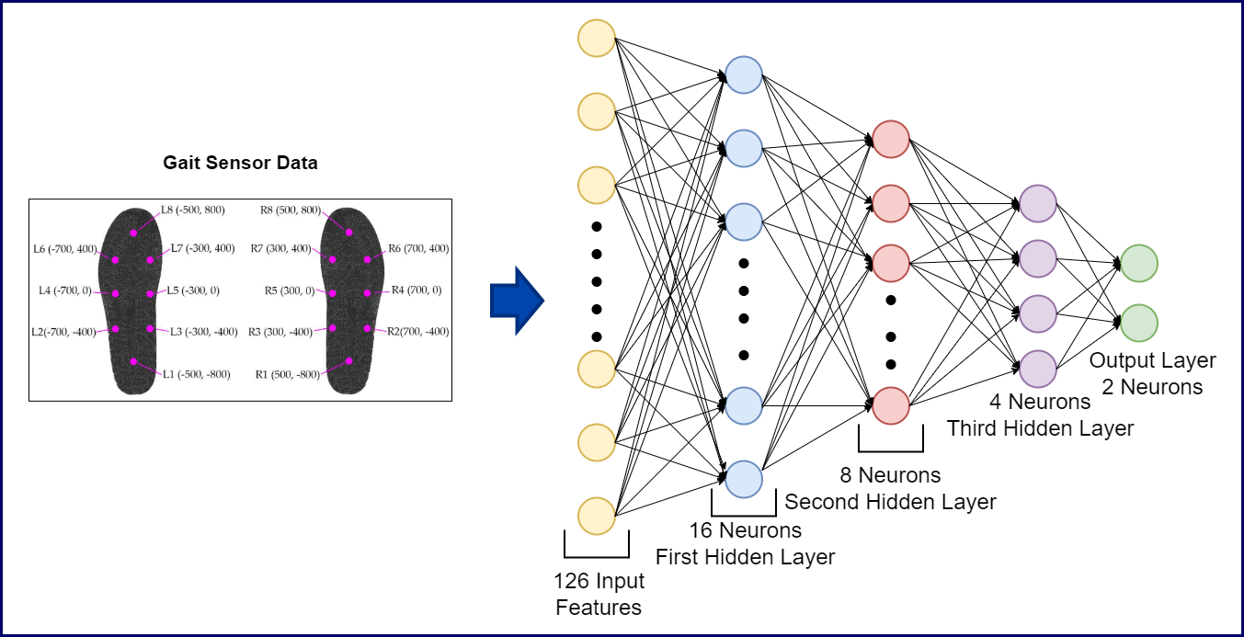

*Fig 2: Gait Data Neural Network Model*

* The second layer is another 1D convolutional layer with shape 16 and "Replay" activation function.
* The third layer is a drop layer with a drop probability of 0.3.
* The next layer is a 1D convolution layer with shape 8 and activation function "Replay".
* The fifth layer is a simple layer with a break probability of 0.3.
* Then the next layer is a fully connected dense layer with shape 4 and activation function set to "Player".
* And the output layer is also a fully connected dense layer with an output shape of 2 and an activation function of "SoftMax".

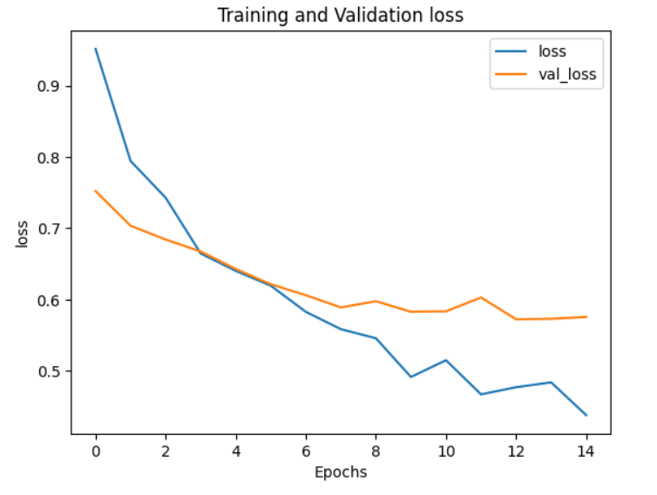

*(a) Training and Validation loss*

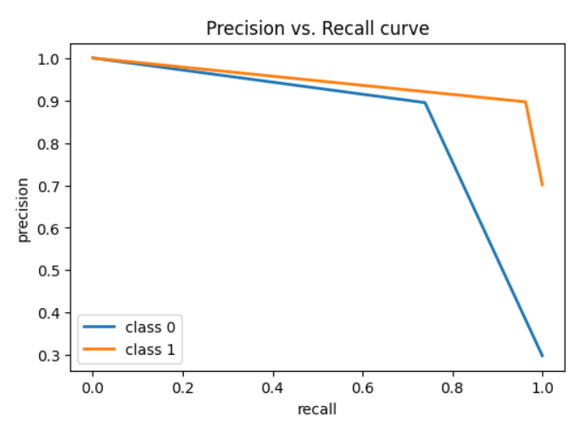

*(b) Precision vs. Recall curve*

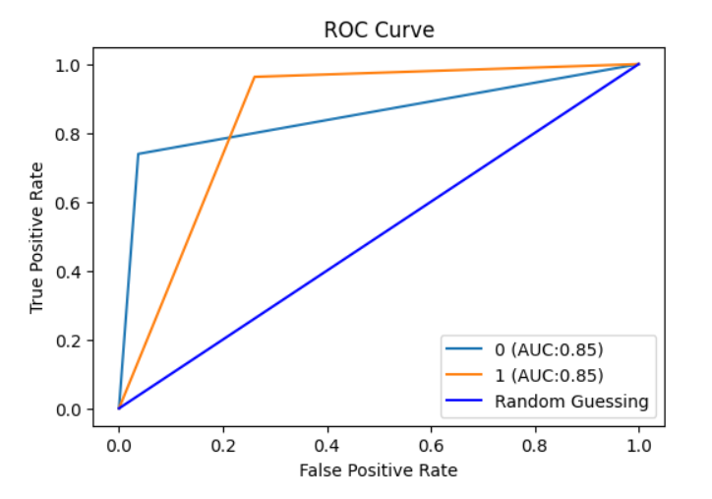

*(c) ROC Curve*

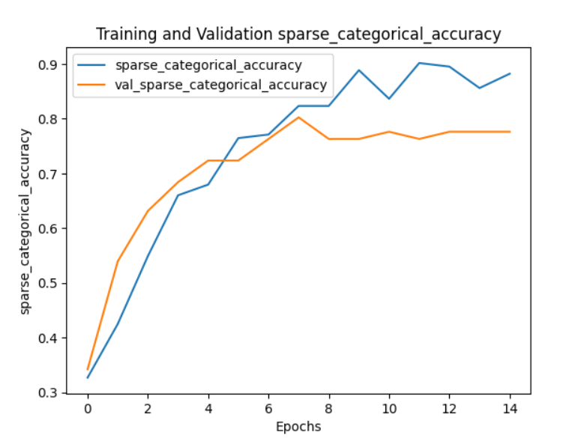

*(d) Training and Validation accuracy*

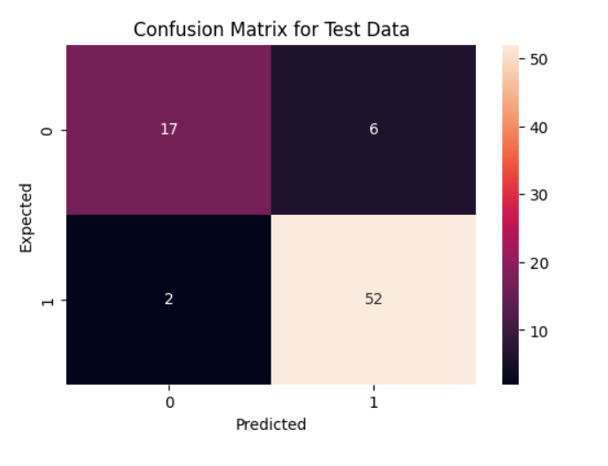

*(e) Confusion Matrix on Test Data*

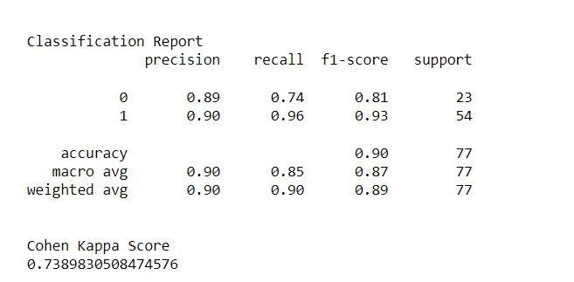

*(f) Classification Report*

*Fig 3. Result using Gait Model on Gait data:*

When building the model, we chose the "Sparse Categorial Cross-Entropy" loss function with the "RMSprop" optimizer and a learning rate of 0.0001. We ran this model for 15 periods with a group size of 5 and achieved 89.61% accuracy with a Cohen Kappa score of 0.7389 and a ROC AUC score of 0.8510. From the confusion matrix of the test data above, we can see that the number of false positive classes of PD patients detected by healthy individual patients is much higher than the false negative case. If the model detects negative PD, it is difficult to apply it in critical clinical diagnosis. Also, the ROC accuracy did not exceed 90%, so we need to consider building a more complex model to understand the underlying data pattern.

* 1. **Multi Modal Analysis:**

After testing on a single dataset, we achieved 89% accuracy on the Gait dataset and 91% accuracy on the PPMI dataset, but we can see that the error rate is still very high in both cases. To this end, we tried to explore recent developments in machine learning multimodal analysis where we can jointly classify patient data. In this context, we tried to prepare data using both datasets. In the next section, we described the data generation technique for multimodal architecture.

**5.3.1 Data Generation:**

We have organized this process into several steps for clarity. Initially, we simplify the Gait sensor data to facilitate integration with the PPMI data.

* We start by applying seven key statistical methods to each sensor data column: minimum, maximum, mean, median, standard deviation, skewness, and kurtosis.
* The entire time series data for each subject is condensed into a single row, resulting in 126 attributes (each attribute converted into 7 columns). For the PPMI dataset, we considered data from 7 visits and a baseline visit for motor and non-motor symptoms, yielding 1595 features.
* For the PPMI dataset, we focus on data from 7 visits and a baseline visit for motor and non-motor symptoms, amounting to 1595 features.
* Pacing patients comprise a group of 93 PD and 73 HC patients, while PPMI includes 294 PD and 154 HC patients.
* Prior to merging, we divide both datasets based on class distribution.
* By performing a cross-product between the two datasets for each class, we create a combined dataset.
* We allocate 50% of the data for training, 25% for validation, and the remainder for testing across all datasets.
* This results in a total of 9484 data points for training, 2363 for validation, and 2517 for testing, with 1721 features after splitting and cross-matching.

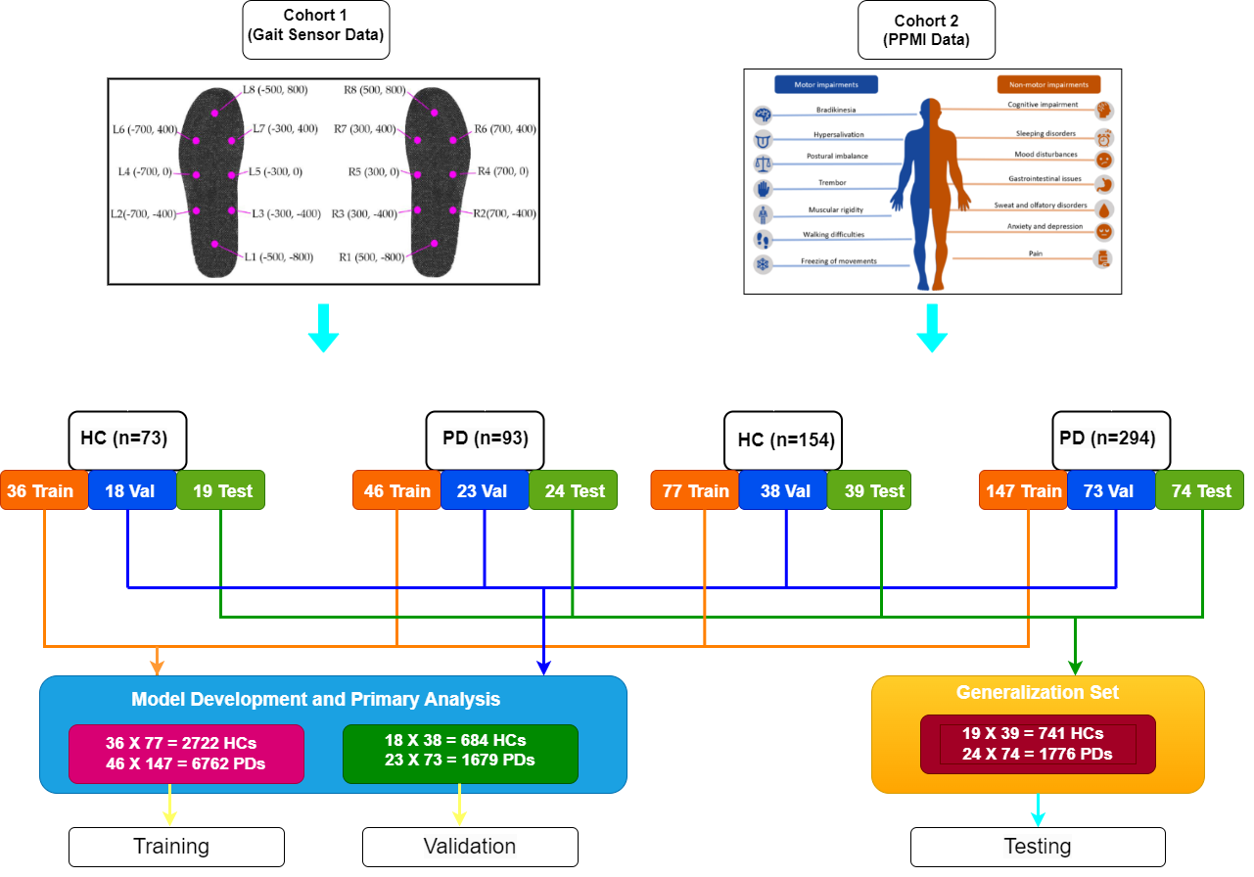

*Fig. 6: Data Generation Diagram.*

**5.3.2 Triplet Loss:**

Triplet loss function's goal is to learn from the distributed embeddings representation of data points in a way that projects relatively similar data points near one another while projecting dissimilar data points far apart in high dimensional vector space. The following is the formula:

*L = max(d(a, p)−d(a,n) +margin,0)*

The illustration explains how to compute triplet loss, which in turn aids in network gradient measurement. The variables "a" and "p" stand for the anchor sample, positive sample, and negative sample, respectively. We are aware that there should be a greater similarity between a and p than a and n.

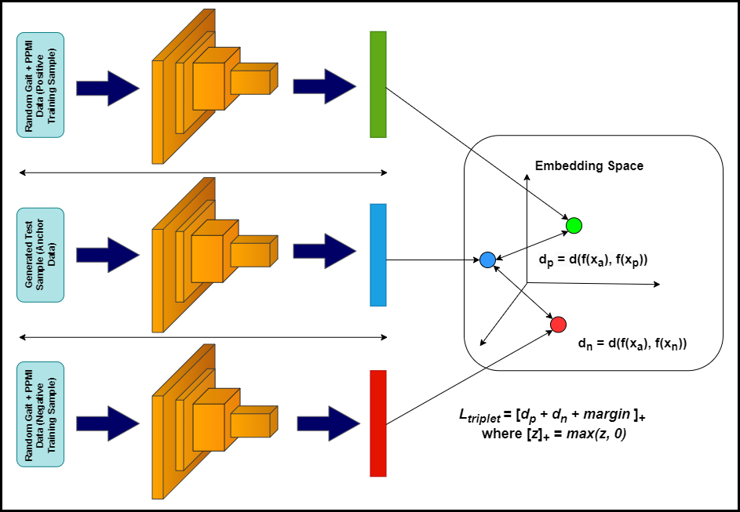

*Fig 7: Triplet Loss Diagram.*

The loss function also has a hyperparameter named margin

added to it. This hyperparameter indicates the minimum distance at which the differences must exist. It helps us identify two samples considerably more quickly. Gradients are eventually measured, and this information is useful in updating the Siamese network's weights and biases. We gather an anchor sample, a random positive sample, and a random negative sample throughout the training phase to compute loss and update the network's gradients.

**5.3.3 Training Data Preparation:**

A positive sample (whose label should match the anchor sample), a negative sample (whose label should match the anchor sample), and an anchor sample are required to make triplets of. There are two classes in both PPMI and Gait dataset. Therefore, two samples are randomly chosen from the same set for each combination of Gait and PPMI data (considered the anchor sample) from the train set; one sample is taken from the same class as the anchor sample (considered the positive sample), and the other sample is taken from a different class (considered the negative sample) from the training set. Additionally, we have chosen n number of triplets for each batch.

**5.3.4 Multi-Modal Architecture:**

When dealing with two different pieces of information, we should consider combining two architectures such as Gait and PPMI to create a framework that can handle all functions. This model can extract features from two different networks and combine those features and pass them through the federated network, where an appropriate loss function predicts its title. We applied the idea of ​​a metric space method to detect whether a pair of data is similar or not. That is why a Siamese metric comes into the picture, which can calculate the difference between two embedding vectors and pass it through an energy function and predict whether a pair is similar or not. A model is proposed that uses two other small architectures as a backbone to help build feature vectors for the Siamese network. Since we have already discussed individual walks and PPMI neural network models, we will not discuss these models again in this section. When feeding a Siamese network, which is basically a framework that uses more than one inputs, we think of extracting the second last layer from the walking and PPMI datasets as modified feature vectors for multimodal feeding. These feature vectors individually have the characteristics of step analysis and PPMI diagnostic values, which are combined before being treated as an input to the Siamese network. Together, the Gait and PPMI functions generate 36 feature vectors (4 vectors from the Gait model and 32 from the PPMI model) and we consider the input to the Siamese network. The Siamese network now also has its own network architecture, which is discussed below:

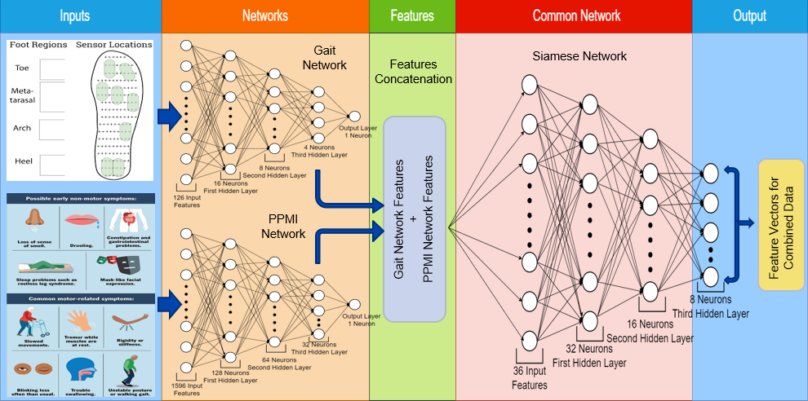

*Fig 8: Siamese Network Diagram.*

* An input layer including 36 dimensions derived from the PPMI and Gait networks.
* Following is a dense layer with size 32 and "Relu" as the activation function.
* Subsequently, a dropout layer with a rate of 0.5 is present, followed by an additional dense layer with a kernel size of 16 and a Relu activation function.
* Finally, we have a dense layer with a kernel size of 8 and the same activation function as before, which is followed by a dropout layer with a rate of 0.5.

**5.3.5 Result:**

In this setup, we employed the RMSprop optimizer with a learning rate set to 0.0001 to construct our model. After building the model, we validated its performance using multiple training sets selected randomly. The training process extended over 30 epochs, with each training set comprising 128 samples. To assess the model's accuracy, we utilized the cosine similarity method on various test sets, revealing a positive similarity of 97.45% between anchor and positive samples, and a negative similarity of 95.06% between anchor and negative samples.

For real-world validation, we collected gait and PPMI data from the test set without labels. Subsequently, to evaluate the model's performance solely based on gait data, we randomly selected 5 positive (PD patients) and 5 negative (HC patients) PPMI data from the training set, combining them into individual gait test samples. This resulted in 10 (Gait) + PPMI samples from each walk, serving as the anchor of the triple model. Positive and negative samples were then extracted from the training set, consisting of combined Parkinson's disease patient data and Healthy Control patient data. This setup yielded 10 triplet pattern outputs versus 10 triplet inputs for thorough evaluation.

*Fig 9: Model Testing Flow Diagram.*

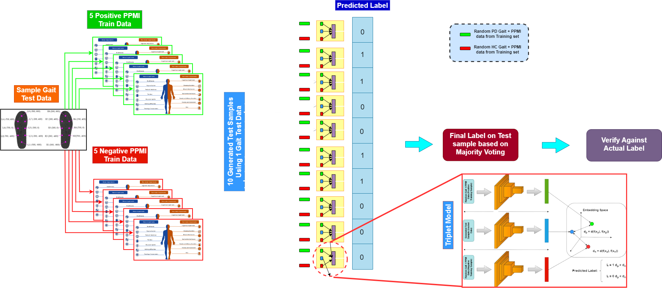

The model follows a triple loss paradigm, generating labels based on the comparison of distances between anchor, positive, and negative samples. Outputting 1 if the distance between anchor and positive is shorter than anchor and negative, and 0 otherwise, each 10-triple model produces 10 labels. These labels are aggregated using a majority voting technique to determine the predictive label for the walk test data. A similar method is applied to PPMI test data, where each test sample is compared against 5 positive (PD patients) and 5 negative (HC patients) samples. Following this, the predicted outputs for both pacing and PPMI test set data are cross-referenced with the

actual labels to evaluate the model's accuracy.

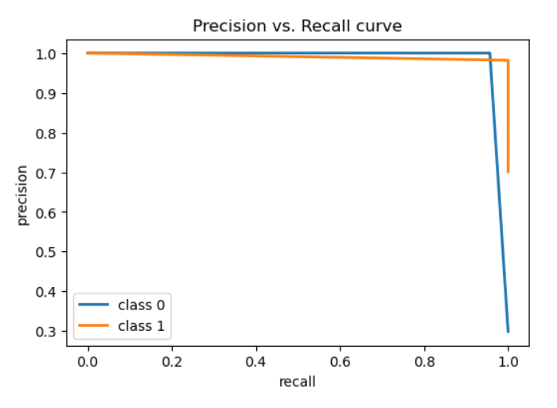

*a) Precision vs. Recall curve*

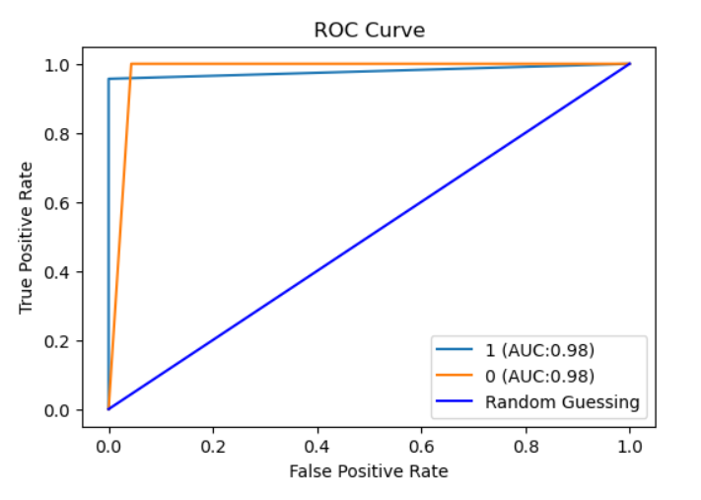

*(b) ROC Curve*

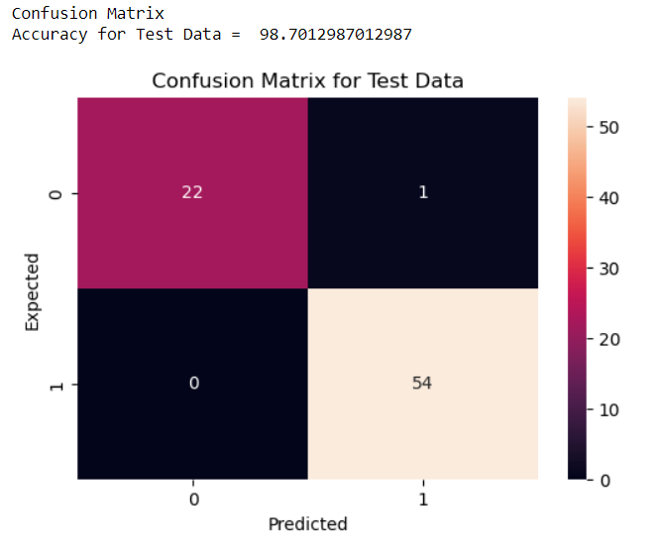

*(c) Confusion Matrix*

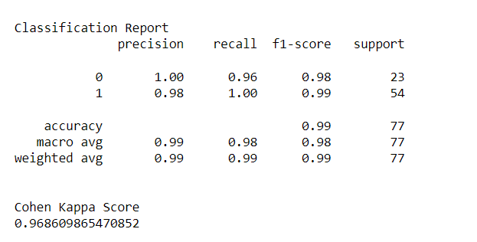

*(d) Classification report on Gait test data.*

*Fig 10. Gait Test Data Results*

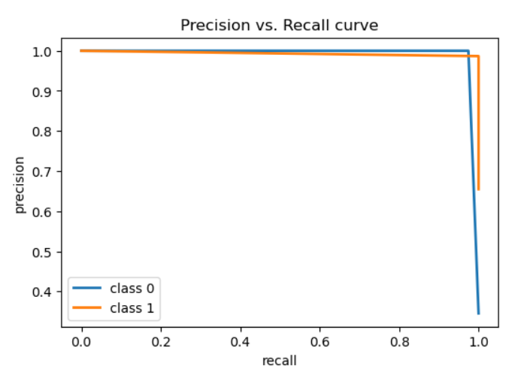

*(a) Precision vs. Recall curve*

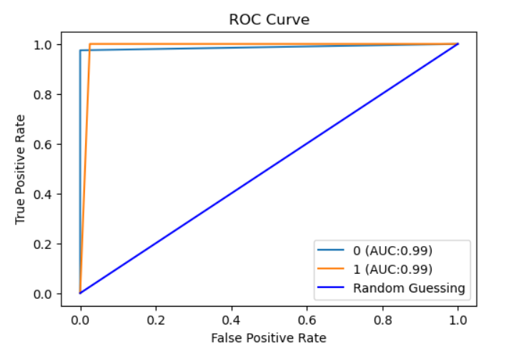

*(b) ROC Curve*

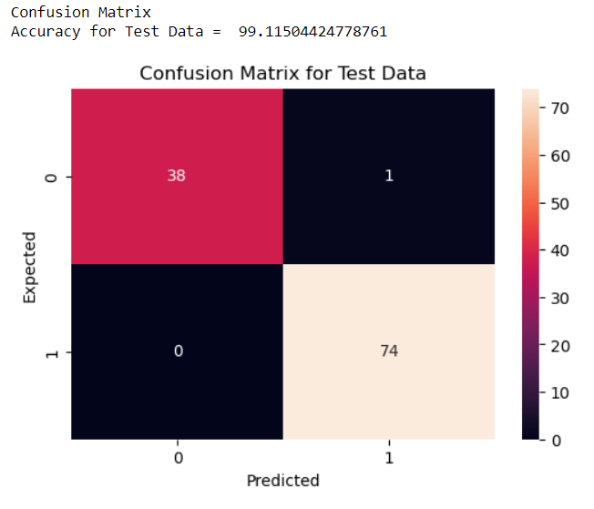

*(c) Confusion Matrix*

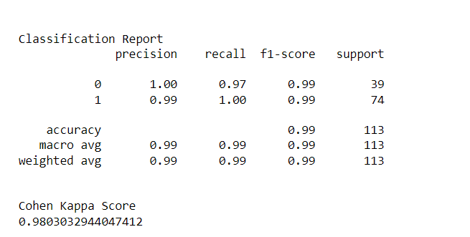

*(d) Classification report on PPMI test data.*

*Fig 11: PPMI Test Data Results*

We have obtained a 98.7% accuracy rate, a Cohen kappa score of 0.9686, a ROC AUC score of 0.9782, a sensitivity of 95%, and a specificity of 94% for the Gait test samples. Conversely, for the test set samples from the PPMI, the model yielded accuracy of 99.23%, Cohen Kappa score of 0.9613, and ROC AUC score of 0.9864, along with sensitivity of 98% and specificity of 97.36%. Therefore, it is clear from our earlier research on a single dataset and model that the suggested architecture, when combined with those multi-modal features, was able to increase ROC AUC value and accuracy.

1. **Conclusion**

In conclusion, the intersection of deep learning techniques and multi-modal data fusion represents a promising frontier in the diagnosis and management of Parkinson's Disease (PD). Through the integration of diverse data sources such as gait sensor data, brain MRI images, genetic information, and clinical records, researchers have made significant strides in enhancing diagnostic accuracy and understanding the underlying mechanisms of PD. The findings of this study underscore the potential of such approaches to revolutionize PD diagnosis by capturing a more comprehensive picture of the disease's progression and enabling personalized treatment strategies. Moreover, the utilization of explainable AI techniques holds promise for enhancing the interpretability and trustworthiness of diagnostic models, paving the way for their seamless integration into clinical practice.

However, it is essential to recognize that the translation of AI-based diagnostic tools from research settings to real-world clinical practice requires careful validation, regulatory approval, and collaboration with healthcare stakeholders. Future research efforts should prioritize the validation of developed models on diverse and representative populations to ensure their generalizability and effectiveness across different demographic groups. Furthermore, ongoing exploration of longitudinal data and the incorporation of additional modalities could provide further insights into disease progression and therapeutic response prediction, ultimately improving patient outcomes. By addressing these challenges, the field stands poised to harness the full potential of AI in advancing the diagnosis of Parkinson's Disease, with the goal of improving the quality of life for individuals affected by this debilitating condition.

1. **Future Work**

Future research on Parkinson's disease (PD) diagnosis and treatment has great potential to advance clinical practice and our present understanding of the condition. An important line of inquiry is the incorporation of modalities other than brain MRI pictures and gait sensor data. Researchers can develop a more thorough understanding of the underlying mechanisms and biomarkers of Parkinson's disease (PD) by combining genetic data, clinical records, and other neuroimaging techniques. This could result in the development of more precise diagnosis models. Additionally, longitudinal studies that monitor the course of an illness over time may offer priceless insights into early disease signs and individualised treatment plans, empowering medical professionals to customise therapies based on the needs of each patient.

The application of such models in actual clinical situations is a crucial component of next study. Collaboration between scientists, physicians, and business partners is crucial to achieving this. In addition to regulatory approval procedures, rigorous validation on a variety of representative populations will be required to guarantee the validity and applicability of AI-based PD diagnostic tools. Furthermore, the use of explainable AI techniques might improve doctors' confidence in and comprehension of model decisions, allowing for a smooth integration into the current healthcare system. Future

research initiatives could have a substantial impact on

Parkinson's disease (PD) diagnosis and management by tackling these areas of investigation, which would ultimately improve patient care and results

1. **Comparison**

Next, we compared our model to several other earlier studies that were conducted using already seen Gait dataset and nearly identical attributes gathered from PPMI datasets. We have attempted to confirm how our multi-modal analysis experiment compares to those findings to provide a summary of the model's capacity to identify data while some modalities are missing. Comparisons for outcomes using the Gait and PPMI dataset are shown below.

Table 1: PPMI Comparison

|  |  |  |  |  |  |  |
| --- | --- | --- | --- | --- | --- | --- |
| **Research Model** | **Method** | **Year** | **AUC** | **Sp. (%)** | **Sn. (%)** | **Acc. (%)** |
| **Prashantha et al.** | SVM | 2016 | 98.88% | 95.01 | 97.03 | 96.40 |
| **Hema et al.** | Random Forest | 2023 | 97.00% | 89.20 | 93.40 | 95.40 |
| **Cingireddy et al.** | Random Forest | 2022 | NA | NA | NA | 98.00 |
| **Leger et al.** | GAM | 2020 | 94.60% | 85.00 | 92.30 | 89.80 |
| **Proposed** | Multi-Modal | 2024 | 98.95% | 97.36 | 98.00 | 99.115 |

The comparison table reveals that our recent experiment with the PPMI dataset has notably surpassed all previous benchmarks in terms of accuracy levels. This design has outperformed earlier studies across various metrics, including

AUC score, sensitivity, and specificity. However, when assessing the Gait dataset, a different scenario emerges. Previous research achieved an accuracy rate exceeding 99%, and our experiment's results closely mirror those findings.

Table 2: Gait Comparison

|  |  |  |  |  |
| --- | --- | --- | --- | --- |
| **Authors** | **Year** | **Sp. (%)** | **Sn. (%)** | **Acc. (%)** |
| **Priya et al.** | 2020 | NR | NR | 98.82 |
| **Liu et al.** | 2021 | 100 | 98.04 | 99.22 |
| **Ghaderyan and Fathi** | 2021 | 95.86 | 98.22 | 97.22 |
| **Zeng et al.** | 2016 | 98.63 | 98.92 | 98.8 |
| **Xia et al.** | 2020 | 99.01 | 99.1 | 99.07 |
| **Açuroglu et al.** | 2018 | 99.5 | 97.8 | 99 |
| **Tong et al.** | 2021 | NR | NR | 99.23 |
| **Veeraragavan et al.** | 2020 | 97.41 | 97.05 | 97.7 |
| **Zhao et al.** | 2018 | NR | NR | 98.61 |
| **Proposed** | 2024 | 99.70 | 98.31 | 98.70 |

Additionally, the evaluation metrics of sensitivity, specificity, and F1 Score closely resemble those of previous research studies. Consequently, we can infer that our framework did not significantly surpass these outcomes, as current research

experiments have already achieved close to 100% accuracy. Therefore, there is presently little room for improvement with the Gait Dataset.

**References**

1. Zeng, W., Liu, F., Wang, Q., Wang, Y., Ma, L., & Zhang, Y. (2016). Parkinson’s disease classification through gait analysis using deterministic learning. Neuroscience Letters.

2. Leger, C., Herbert, M., & DeSouza, J. F. X. (2020). Early PD detection with high cross-validated accuracy enabled by non-motor clinical and biomarker predictors. Frontiers in Neurology.

3. Zhao, A., Qi, L., Li, J., Dong, J., & Yu, H. (2018). A hybrid spatiotemporal model for detecting and rating Parkinson’s disease severity from gait data. Neurocomputing.

4. Açici, K., Erdas, C. B., Asuroglu, T., Toprak, M. K., Erdem, H., & Ogul, H. (2017). Detection of Parkinson’s disease via gait analysis using a random forest method. Engineering Applications of Neural Networks.

5. Liu, X., et al. (2021). Detecting Parkinson’s disease by analyzing independent and combined characteristics of the left and right gait through a dual-branch model.

6. Ghaderyan, P., & Fathi, G. (2022). Inter-limb time-varying singular value: A novel gait feature for Parkinson’s disease detection and stage classification. Measurement: Multimedia Tools and Applications.

7. Noella, N., Gupta, D., & Priyadarshini, J. (2019). Gait dynamics and image analysis for Parkinson’s disease diagnosis. Proceedings of the International Conference on Recent Trends and Advances in Computing.

8. Asuroglu, T., Acici, K., Erdas, C. B., Toprak, M. K., Erdem, H., & Ogul, H. (2018). Parkinson’s disease monitoring via foot-worn sensor gait analysis. Biocybernetics and Biomedical Engineering.

9. Xia, Y., Yao, Z., Ye, Q., & Cheng, N. (2022). Quantification of Parkinson’s disease characteristics using a dual-modal attention-enhanced deep learning network. IEEE Transactions on Neural Systems and Rehabilitation Engineering.

10. Glaab, E., Trezzi, J. P., Greuel, A., Jäger, C., Hodak, Z., Drzezga, A., Eggers, C. (2019). Integrative analysis of blood metabolomics and PET brain neuroimaging data for Parkinson’s disease. Neurobiology of Disease.

11. Cherubini, A., et al. (2014). Discrimination between Parkinson’s disease and progressive supranuclear palsy using magnetic resonance support vector machine. Proceedings of the International Parkinson and Movement Disorder Society.

12. Priya, S. J., Rani, A. J., & Ubendran, N. (2020). Enhancing Parkinson’s disease prediction accuracy using pattern techniques. The proceedings of the fifth international conference on devices, circuits, and systems.

13. Hema, M. S., Maheshprabhu, R., Reddy, K. S., Guptha, M. N., & Pandimurugan, V. (2023). Parkinson disease prediction analysis using multiple feature selection and classification methods. Multimedia Tools and Applications.

14. Veeraragavan, S., Gopalai, A. A., Gouwanda, D., & Ahmad, S. A. (2020). Diagnosis and severity assessment of Parkinson’s disease using ground reaction forces and neural networks. Frontiers in Physiology.

15. A. Amaral, L. Glass, Goldberger, L. Hausdorff, J. Ivanov, P. C., Mark, R. Stanley, H. E. (2000). PhysioBank, PhysioToolkit, and PhysioNet: A new research resource for complex physiologic signals. Proceedings of the CVPR.

16. Cingireddy, A. R., Ghosh, R., Melapu, V. K., Joginipelli, S., & Kwembe, T. A. K. (2022). Classification of Parkinson’s disease using motor and non-motor biomarkers through machine learning techniques. International Journal of Quantitative Structure-Property Relationships.

17. Oliveira, F. P. M., Faria, D. B., Costa, D. C., Castelo-Branco, M., & Tavares, J. M. R. S. (2018). Feature extraction, selection, and comparison for automated computer-aided diagnosis of Parkinson’s disease based on [123I] spect images.

18. Long, D., et al. (2012). Automatic classification of early Parkinson’s disease with multi-modal imaging. PLOS ONE.

19. Hirschauer, H. H., Adeli, T. J., Buford, J. A., & A. Computer-aided diagnosis of Parkinson’s disease using enhanced probabilistic neural network. Journal of Medical Systems.

20. Prashanth, R., Roy, S. D., Mandal, P. K., & Ghosh, S. (2016 Accurate identification of early Parkinson’s disease utilizing a combination of multiple features and machine learning techniques.

21. Du, G., et al. (2017). Differentiation between Parkinson disease and atypical parkinsonism using combined diffusion tensor imaging and apparent transverse relaxation rate. American Journal of Neuroradiology.

22. Tong, J., Zhang, J., Dong, E., & Du, S. (2021). Classifying the severity of Parkinson’s disease using the significance of permutation variables and sustained entropy. Multimedia Tools and Applications.